OPSC 7311 Assignment 2

2017

Adrian Beukes 15002426

**Content**

Introduction ………………………………………………………………………..2

Specifications ………………………………………………………………………..2

Flow Charts ………………………………………………………………………..3

UML Diagrams ………………………………………………………………………..4

Test Data ………………………………………………………………………..5

Help ………………………………………………………………………..8

Feedback ………………………………………………………………………..8

Conclusion ………………………………………………………………………..9

**Introduction:**

The purpose of this assignment is to develop a simple database Application, one that would be easy to use, understand, and doesn’t place too much stress on the hardware.

I decided to go with a simple store stock app, for a surf shop. In my application you can Do all possible CRUD ‘s. while going from one activity to another without a problem.

**Specifications:**

Functional Requirements:

The requirements for this project:

* Keep it simple
* Don’t strain the hardware
* Make use of a database
* Add to database
* Read database
* Update database
* Delete entries
* Show prompts that each are successful
* About File

**Flow Charts:**

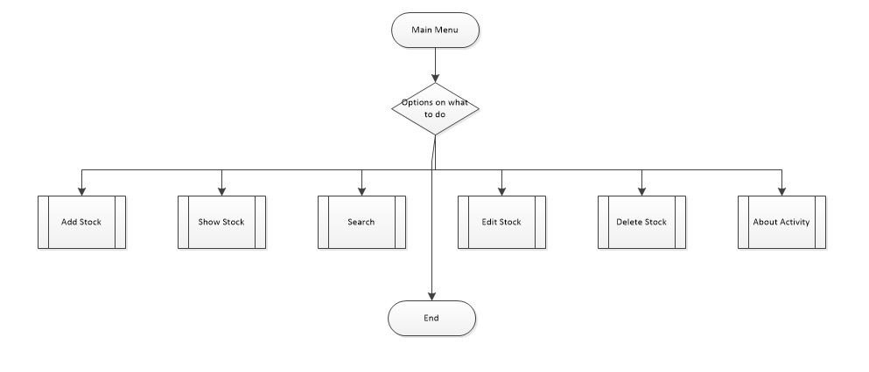

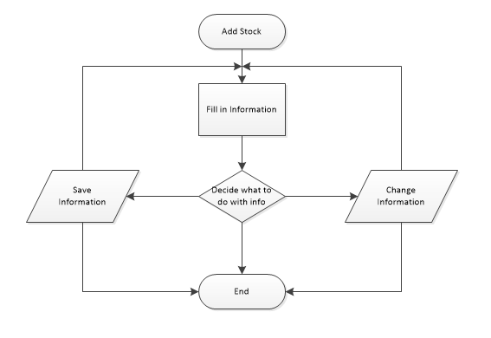

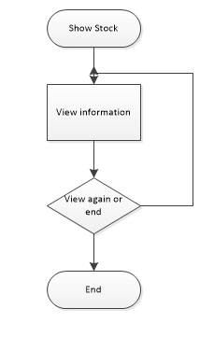

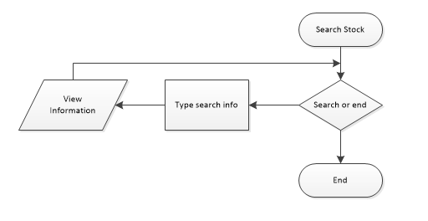

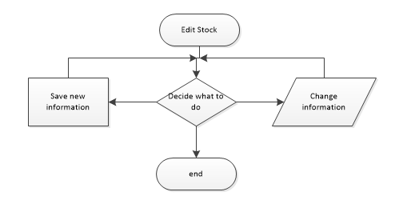

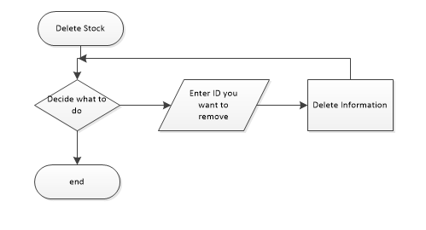

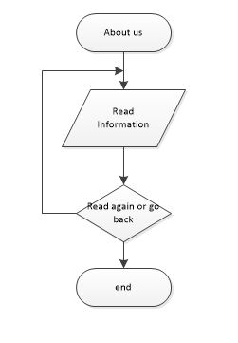

**UML Diagrams:**

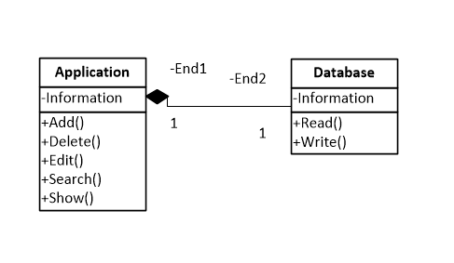

**Test Data**

A few screenshots of my program will follow, with explanation of what’s happening at each stage, as I progress in order to test it:

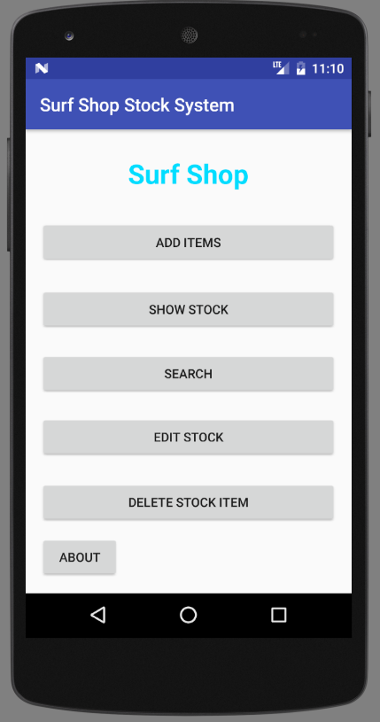

This is the main menu for my application, from here you can do all possible crud’s for your store, followed by viewing your stock, and searching for it. As well as a about guide telling you more about the application.

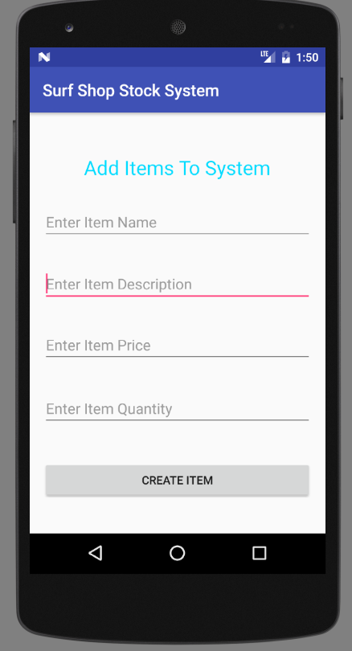

This is the add activity, where you can enter the information about your product. And create it on the database afterwards. Which upon success would prompt you with a message as follow.



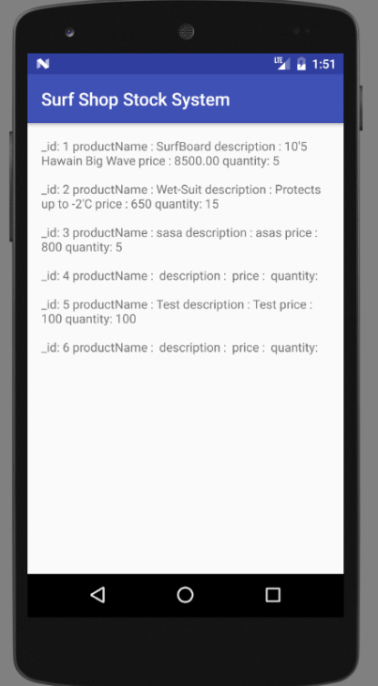

This is the show all stock activity, where you can scroll through, and see what is happening for each item.

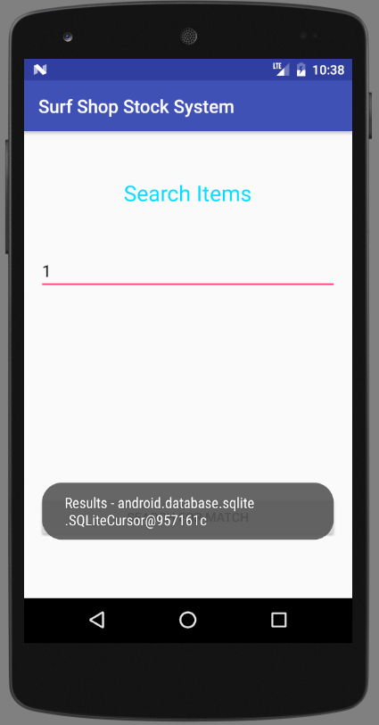

The search can be used to search by any information, it will then bring up a prompt with all possible matches.

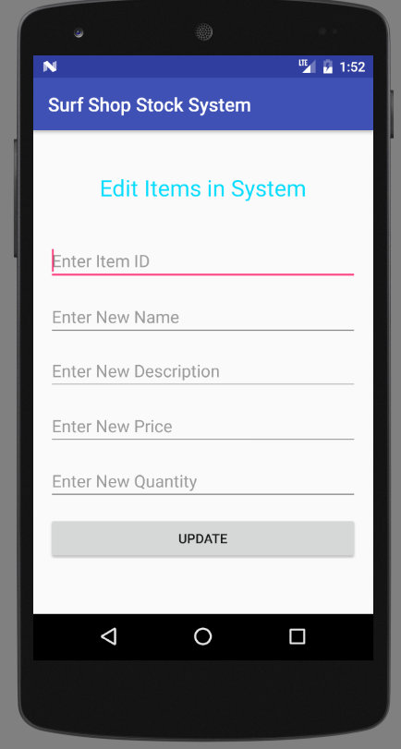

This is the edit, where you need to enter Your item ID for edit, and then you can edit each field to the value you want.

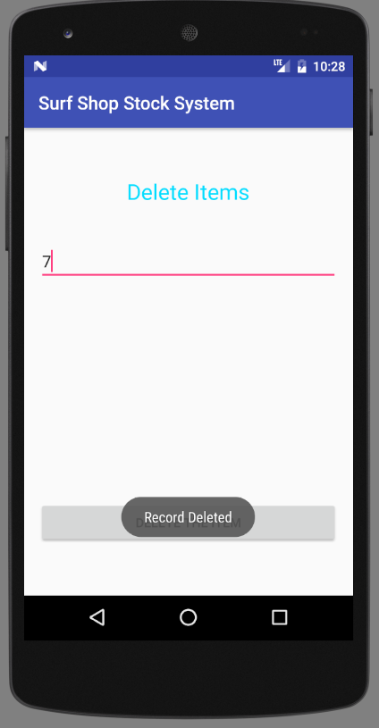

In my delete screen you need to provide the item ID you want to remove.

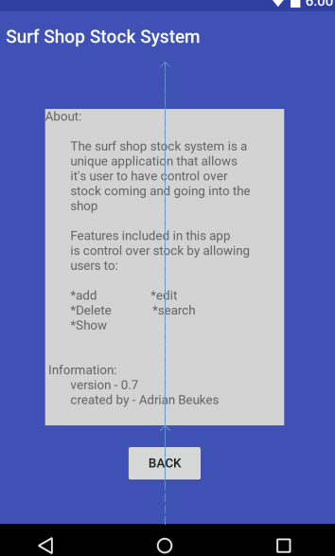

In my about screen you can see more information about the application and navigate back to the main screen from here.

**Help:**

This is a guide that would take you step for step through the application.

On opening the application you will find yourself at the Home/Main Menu Activity.

Here you will find yourself with the option, to create a new note immediately without the stress of searching where to type

You also have a general information typing space for all other information.

After you’ve completed your note, it can then be saved to the text file with a simple button click.

It will prompt the user upon success.

Afterwards you can view all previously saved notes and scroll through them to the important one

**Feedback:**

|  |  |
| --- | --- |
| Comments | Reaction |
| Data Validations | Changed for appropriate data types in xml file |
| Errors | Fixed all errors, tested and is working |
| Description field in focus with add | Can’t see that this is happening, there is good flow in the UI |
| Better layout for report | I kept with scroll view, for mobile I think it’s better to have a scroll instead of having everything pressing against each other in a table view and you have to zoom to read the information. One hand operating is better than 2 hand operating in most cases |

**Conclusion:**

I really learned a lot from the database assignment and it improved my method of where I will be storing most of my data for any future application.

I believe the database is a lot safer way of storing information rather than a text file.

I also learned a lot from other people’s feedback and how it helps me with the developing of my application, and what to pay attention too in the future.